Appendix A – Safety Tag Reference Guide

Tag or lock | Used by
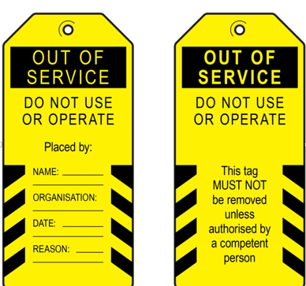 | All workers/manager
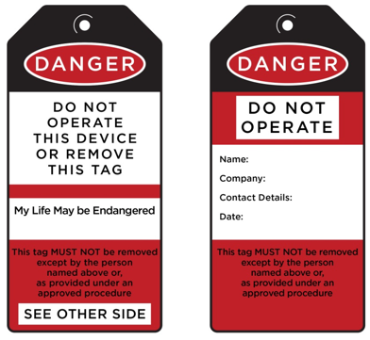 | Licensed repairer or trades
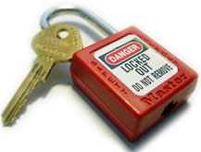 | Trades person only.
- 