**APPENDIX 1: OCCUPATIONAL HYGIENE MONITORING PROGRAM OVERVIEW**

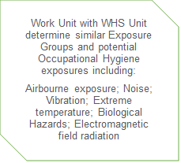

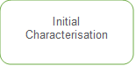

Shape

Shape

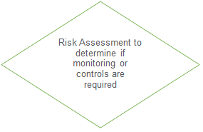

Text Box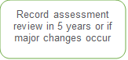

Shape

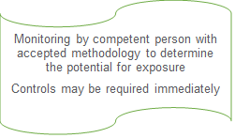

Shape

Text Box

Shape

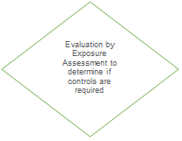

Text Box

Shape

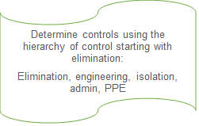

Text BoxShape

Shape

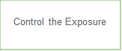

Shape

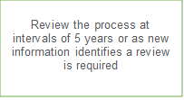

**APPENDIX 2: QUALITATIVE RISK RATINGS**

|  |  |  |
| --- | --- | --- |
| **Risk Rank/Level** | **Estimated Exposure** | **Action Required** |
| High | Possibly exceeding the OES | Immediate controls |
| Medium | Possibly exceeding 50% of OES | Further review and monitoring |
| Low | Possibly exceeding 10% of OES and less than half the OES | Further review and monitoring |
| Very Low | Unlikely to exceed 10% of OES | No further action |
| Not applicable | Not applicable to that SEG | No further action |