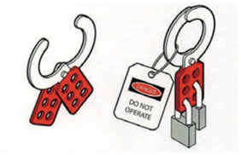
Figure 1: Example of Lock out and Tag

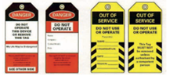
Figure 2: Example of Danger Tags

