WHSMS Overview Manual – Associated Information

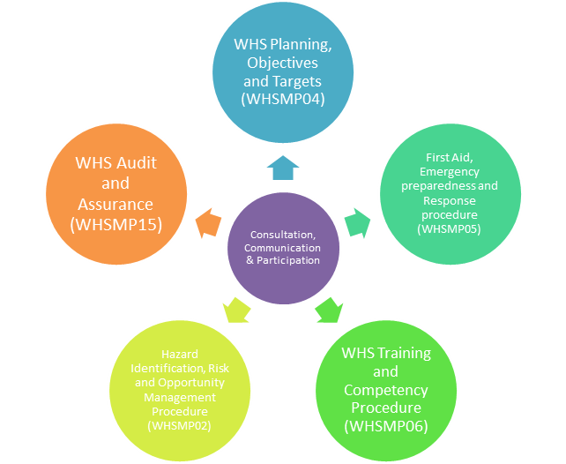

Figure 1: Employee Participation overview

Figure 2 Hierarchy of Controls

**Appendix 1: WHSMS Documents and Procedures**

|  |  |  |  |
| --- | --- | --- | --- |
| **Element #** | **Element** | **Documentation** | **Document Overview** |
| **1** | Organisational Context | WHSMP12: WHS Overview Manual | Overview of the SCU WHSMS, including scope, interested parties, context and all elements of an ISO45001 aligned system. |
| **2** | Leadership and Commitment | WHSMP01: WHS Leadership and Culture | Procedure to outline the required activities to be undertaken by management to demonstrate leadership in regards to WHS aspects and review performance, resources, and needs of the organisation to support continual improvement. |
| WHS Policy | Commitment from top management towards health, safety and welfare.   It is the statement of intent on which the management system aims to deliver. |
| WHSMP13: WHS Responsibility and Accountability Statements | Procedure to outline the roles, responsibilities and accountability statements for all levels of the organisation. |
| **3** | WHS Objectives and Planning | WHSMP02: Hazard Identification, Risk and Opportunity Management Procedure | Procedure that describes the process of how the organisation will effectively identify, assess, and control H&S risks.  Includes development of supporting templates. |
| WHSMP03: WHS Legal and Other Requirements Procedure | Procedure that sets out the requirements to effectively identify, monitor and review the organisations H&S legal and other requirements to ensure legislative requirements are met. |
| WHSMP04: WHS Planning, Objectives and Targets | Procedure that outlines the requirements to set H&S objectives and targets for continual improvement of which the organisation reviews its performance against. |
| WHSMP05: First Aid, Emergency preparedness and Response procedure | Procedure to outline the process and requirements associated with emergency response preparedness,  planning and testing of proposed response to various scenarios; process and requirements for first aid provision. Includes development of supporting templates. |
| **4** | Support | WHSMP06: WHS Training and Competency Procedure | Procedure that sets out the minimum requirements regarding the need to onboard and induct workers to make them aware of the applicable risks, ensure those undertaking tasks have the required competencies, and train workers to ensure safe work practises. |
| WHSMP07: WHS Consultation, Communication and Participation Procedure | Procedure that outlines the process to elect HSRs, manage and resolve issues, and communicate with workers on H&S matters. |
| WHSMP08: Document and Records Management Procedure | Procedure that outlines the document and records management at SCU. |
| **5** | Operational Control | WHSMP09: Permit to work - Hazardous Work | Procedure to outline the requirements for Permit to Work systems. |
| WHSMP10: Management of Change Procedure | Procedure that sets out the requirements to effectively identify, monitor and review the organisations requirements during change management. |
| WHSMP11: Purchasing and Contractor WHS Procedure | Procedure outlining the requirements to effectively manage H&S risks associated with the engagement of onsite contractors and procurement of materials. |
| WHSMP12: WHS Overview Manual (see above) |  |
| WHSMP13: WHS Responsibility and Accountability Statement (see above) |  |
| WHSMP14: WHS Monitoring, Measurement and Reporting Procedure | Procedure that sets out monitoring, measurement and performance reporting requirements |
| **6** | WHSMS Performance Evaluation | WHSMP15: WHS Audit and Assurance | Procedure to outline the need for workplace inspections, audits and inspections to identify potential and actual hazards, validate the implementation of critical controls, and validate compliance to regulatory requirements. |
| WHSMP16: WHSMS Management Review | Procedure that outline the required activities to be undertaken by management to demonstrate leadership in regards to H&S aspects and review performance, resources, and needs of the organisation to support continual improvement. |
| **7** | WHSMS Improvement | WHSMP17: Incident Management, Reporting and Investigation Procedure | Procedure that describes the process of how the organisation will effectively notify, investigate and report on H&S events.  Includes development of supporting templates. |
|  |  |
| ***Hazard Risk Procedures (operational control element)*** | | | |  | WHS Operational Risks / Critical Risk Modules | Procedure to outline the requirements to eliminate or minimise the risks and events arising from working at heights greater than 2m on site. |
| **8** | HRP01: Psychological health and well being | WHS Operational Risks / Critical Risk Modules | Procedure to outline the requirements to eliminate or minimise the risks of fatalities, injuries and events arising from the management, removal and disposal of asbestos and Asbestos Containing Material (ACM). |
| **9** | HRP02: Working at Heights | Procedure to outline the requirements to eliminate or minimise the risks and events arising from operating and locking out fixed plant and equipment. |
| **10** | HRP03: Asbestos Management | Procedure to outline the requirements to eliminate or minimise the risks and events arising from physical safety and security. |
| **11** | HRP04: Plant & Equipment | Procedure to outline the requriements to eliminate or minimise the risk of fatalities, injuries and events arising from fire. |
| **12** | HRP05: Physical Safety & Security | Procedure to outline the requirements to eliminate or minimise the risks and events arising from using electrical equipment on site. |
| **13** | HRP06: Scheduled Substances and Other Poisons |  |
| **14** | HRP07: Electrical Safety | Procedure that provides guidance on the health and wellbeing of workers and the requirements around presenting fit for work. |
| **15** | HRP08: Hazardous Manual Tasks and Workplace Ergonomics | Procedure that provides guidance on the health and wellbeing of workers and the requirements around presenting fit for work and free from the signs and symptoms of Fatigue. |
| **16** | HRP09: Occupational Health and Hygiene | Procedure to outline the requirements to eliminate or minimise the risks and events associated with the storage, handling, and use of hazardous substances on site. |
| **17** | HRP10: Journey Management | Procedure that provides guidance on the health and wellbeing of workers and the requirements around presenting fit for work and recognising the signs and managing symptoms of Fatigue. |
| **18** | HRP11: Hazardous Chemical Management | Procedure that outlines the requirements to manage biological safety. |
| **19** | HRP12: Fitness for Work | Procedure that outlines the requirements for site establishment (facilitieis and amenities). |
| **20** | HRP13: Biological Safety | Procedure that provides guidance on the selection, providing of, fit, use, storage and disposal of personal protective equipment. |
| **21** | HRP14: Workplace Environment and Facilities | Procedure outlining the process to adequately risk assess and implement controls associated with aviation and drone operations. |
| **22** | HRP15: Personal Protective Equipment | Procedure to outline the requirements to eliminate or minimise the risks and events associated with the use of vessels and maritime activities. |
| **23** | HRP16: Aviation and Drone Operations | Procedure to outline the requjirements to minimise the risks and events arising from diving and underwater work. |
| **24** | HRP17: Vessel and Maritime Safety | Procedure to outline the requirements to eliminate or minimise the risks and events arising from Confined Space works. |
| **25** | HRP18: Diving and Underwater work | Procedure to outline the requirements to eliminate or minimise the risks and events arising from remote working. |
| **26** | HRP19: Confined Spaces | Procedure to outline the requirements to eliminate or minimise the risks and events arising from working in or near deep excavations or trenches (>1.5m) on site. |
| **27** | HRP20: Lone and Isolated Work | Procedure to outline the requirements to eliminate or minimise the risks and events arising from operating and locking out fixed plant and equipment. |
| **28** | HRP21: Excavation and Trenching |  |
| **29** | HRP22: Lock Out, Tag Out |  |