Figure 1. Flow chart to identify confined spaces (from NSW Code of Practice, 2022).

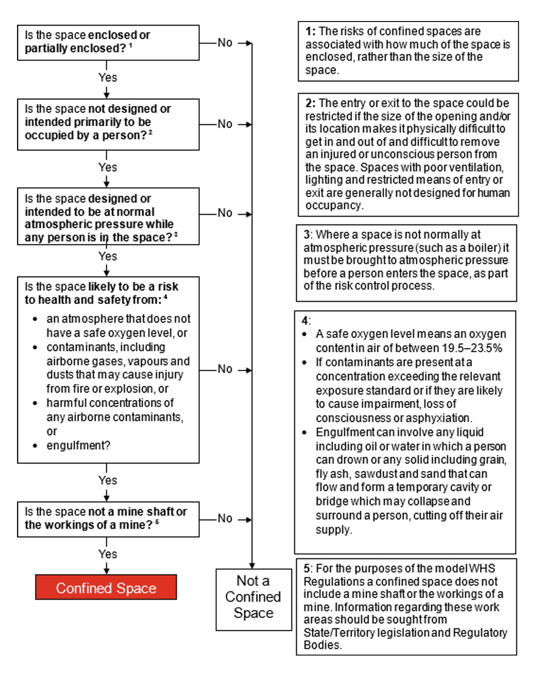

Figure 2

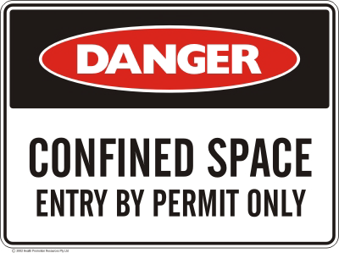

|  |  |  |  |  |  |  |  |
| --- | --- | --- | --- | --- | --- | --- | --- |
| **Appendix A -** Confined Space Criteria | | | | | | | Confined Space? |
| Example of the space and activity | **A** | **B** | **C** | **D** | | | If the answer to A, B, C and at least one of D is yes, then the space is a confined space. |
| Is the space enclosed or partially enclosed? | Is the space not designed or intended to be occupied by a person? | Is the space designed or intended to be, at normal atmospheric pressure while any person is in the space? | Does the space present a risk from: | | |
| Harmful airborne or flammable contaminants | An unsafe oxygen level | Engulfment |
| Sewer with access via vertical ladder | ü | ü | ü | ü | ü | ü | Yes |
| Entering a shipping container to unload or inspect goods | ü | Depends | ü |  | ü |  | No |
| Dislodging a sludge blockage in a drain pit | ü | ü | ü | ü | ü | ü | Yes |
| Inspection of a used tank before decommissioning | ü | ü | ü | ü | ü | ü | Yes |