**WHSMP02 Hazard Identification Risk and Opportunity Management Procedure**

Figure 1

**Risk Assessment Threshold**

|  |  |
| --- | --- |
| **Low** | Risks are below the risk acceptance threshold and do not require active management.  Requires ongoing monitoring by Supervisor. |
| **Moderate** | Risks that lie on the risk acceptance threshold and require active monitoring by the Supervisor and Head of Work Unit. |
| **High** | Risks that exceed the risk acceptance threshold and require proactive management. Approval to start or restart an activity must be given by the Head of Work Unit in consultation with the Manager, Workplace Health and Safety (WHS). |
| **Extreme** | Risks that significantly exceed the risk acceptance threshold and need urgent and immediate attention. Approval to start or restart an activity must be given by the Vice Chancellor or their delegate. |

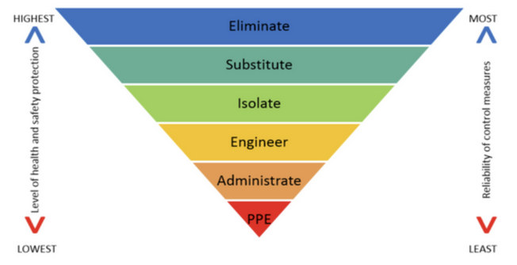

**Level 2 Control Measures**